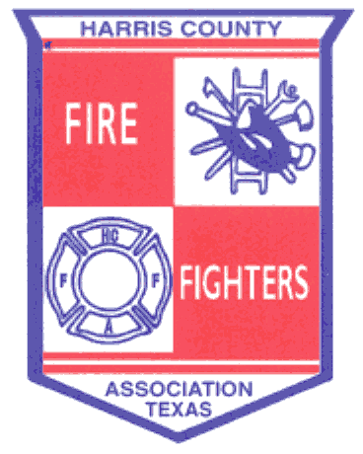 ______________________________________________________________________________
August 21, 2013 Meeting Minutes
- Welcoming – Meeting called to order by Bryan Harris at 19:15 hrs.

- Pledge of Allegiance
- Invocation – Doug Clough
- Roll Call
- Fire Chief Welcoming – Bill Bivens, Atascocita VFD
- Recognition of Guests
- Past Presidents – Montgomery, Ickes, Wade, Anders, Clough
- Good Will Ambassador – Michael Godfrey
- Other Guests – Stuart Norman
- Presentations

- Membership received a presentation from Chief Bob Royall, Harris County Haz-Mat.

- General Business

- Appoint Election Committee for the November Board Election – The positions of “President” and “At-Large” are due for election. Jerry Ickes, Bill Anders and Doug Clough were appointed to the Election Committee.

- Presentation of Reports

- Approval of July Minutes – A Motion was made by David Wade and 2nd by Brian Mulligan to accept the July minutes as presented, carried all in favor.
- Approval of the Financial Report – A Motion was made by Doug Clough and 2nd by Jerry Ickes to approve the July financial report, carried all in favor.

- Report from Area Leadership Groups

  - Northwest Emergency Services Leadership Coalition – No meeting.
  - Northeast Chiefs – General discussion.
  - Bay Area Chiefs – General discussion.

- Training

- See HCFFA website for additional training opportunities.

______________________________________________________________________________

- State TDEM Update – Jenniffier Shields-Hawes
- 300 and 400 training is still available as well as NIMS classes.
- Visit preparingtexas.org for upcoming training and certification courses.

- HCFMO – “Burning Matters” – Jerry Ickes

- Contact Jerry Ickes if your department wants to use the fire field.
- Two fire investigator positions and one fire inspector position added.
- Flash-Over chamber almost complete.
- Con-Ex prop to be done later this year.

- SFFMA Update – David Wade

- Two committees have been chartered, Health & Safety and Combination Department.
- The new building should be open and functional by November/December 2013.

X. Good of the Order

- HCFFA Field Day dates are March 28-30, 2014

XI. Adjournment

A Motion was made by David Wade and 2nd by Mark Zentner to adjourn at 20:35. The Motion carried all in favor.

Future Meetings:

November 20, 2013 – Cloverleaf VFD at the Grayson Center

