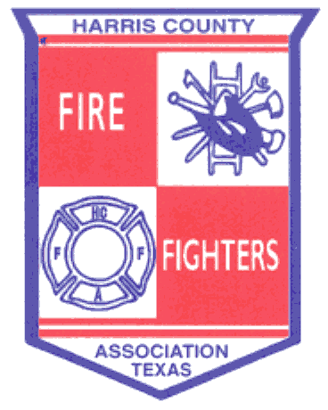 ______________________________________________________________________________
February 19, 2014 Meeting Minutes
- Welcoming – Meeting called to order by Bryan Harris at 19:07 hrs.

- Pledge of Allegiance
- Invocation – Doug Clough
- Roll Call
- Fire Chief Welcoming – Capt. Arnette, Jersey Village FD
- Recognition of Guests
- Past Presidents – Ickes, Wade, Anders, Clough, Montgomery
- Good Will Ambassador – Michael Godfrey
- Other Guests – Cody Griffin, American Red Cross and Bob Janusaitis, ESD 9
- Presentations
- Angie Johnson – Texas DPS, National Public Safety Broadband
- James Bryant – HAZMAT
- Dr. Carol Lewis – TSU Petrochemical Incident Location System
- Jason Herron – Wilson Fire
- Alexa Horak – Planet Ford/Planet Lincoln
- General Business

- 2013 Firefighter of the Year – David Wade
- Approval of November Minutes – A Motion was made by David Wade and 2nd by Doug Clough to accept the November minutes as presented, carried all in favor.
- Approval of the Financial Report – A Motion was made by Tom Linnenkugal and 2nd by Jerry Ickes to approve the November financial report, carried all in favor.
- Advisement of 2014 Dues for membership as voted upon by Board of Directors - $250 per department and $350 for affiliate members.

- Report from Area Leadership Groups

  - Northwest Emergency Services Leadership Coalition – General discussion.
  - Northeast Chiefs – General discussion and held elections.
  - Bay Area Chiefs – Discussed uniforms, SOP’s and SOG’s.

- Training

- HCFFA Field Day dates are March 28-30, 2014.
- See HCFFA website for additional training opportunities.

______________________________________________________________________________

- HCFMO – “Burning Matters” – Jerry Ickes

- Contact Jerry Ickes if your department wants to use the fire field.
- Position openings available for full-time and part-time inspectors.
- HCFMO budget has been approved
- Bi-Annual inspection by the state has been completed.
- Texas Forest Service will be hiring a 6-person dozer crew in Atascocita.
- Good of the Order
- HCFFA Field Day dates are March 28-30, 2014

XI. Adjournment

A Motion was made by Jerry Ickes and 2nd by Doug Clough to adjourn at 21:15. The Motion carried all in favor.

Future Meetings:

May 21, 2014 at Webster FD

