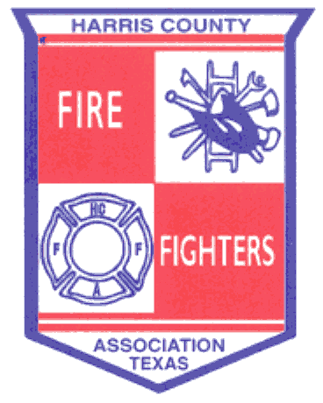 ______________________________________________________________________________
May 21, 2014 Meeting Minutes
- Welcoming – Meeting called to order at 19:12 hrs.

- Pledge of Allegiance
- Invocation – Doug Clough
- Roll Call
- Fire Chief Welcoming – Pat Shipp, Webster FD
- Recognition of Guests
- Past Presidents – Ickes, Wade, Anders, Clough, Montgomery
- Good Will Ambassador – Michael Godfrey
- Presentations
- Deputy Chief Todd Weidman, Webster FD. TCFA Best Practices Accreditation Process
- General Business

- Approval of February Minutes – A Motion was made by Dan Key and 2nd by David Wade to accept the February minutes as presented, carried all in favor.
- Approval of the Financial Report – A Motion was made by David Wade and 2nd by Pat Shipp to approve the February financial report, carried all in favor.

- Report from Area Leadership Groups

  - Northwest Emergency Services Leadership Coalition – General discussion, also looking for a new Fire Chief.
  - Northeast Chiefs – Hosted at Highlands VFD, general discussion.
  - Bay Area Chiefs – No report.

- Training

- HCFFA Field Day dates are May 1 – 3, 2015.
- See HCFFA website for additional training opportunities.

- Other Items for Discussion

- Dan Key, Pres. for Galveston County Assoc. – State Convention in 2015 will be hosted by Galveston County.
- October 16, 2014 – Hot Zone Conference www.hotzone.org

______________________________________________________________________________

- Adjournment
A Motion was made by David Wade and 2nd by Jerry Ickes to adjourn at 20:00. The Motion carried all in favor.

Future Meetings:

August 20, 2014 at West I-10

