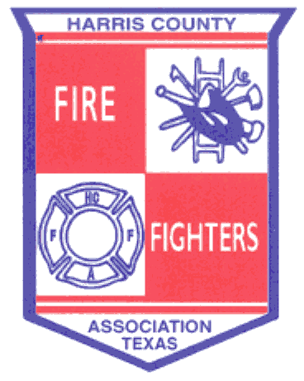 ______________________________________________________________________________
November 20, 2013 Meeting Minutes
- Welcoming – Meeting called to order by Bryan Harris at 19:05 hrs.

- Pledge of Allegiance
- Invocation – Doug Clough
- Roll Call
- Fire Chief Welcoming – Ed Russell
- Recognition of Guests
- Past Presidents – Ickes, Wade, Anders, Clough
- Good Will Ambassador – Michael Godfrey
- Other Guests – American Red Cross
- General Business

- Approval of August Minutes – A Motion was made by Jesse Garcia and 2nd by Doug Clough to accept the August minutes as presented, carried all in favor.
- Approval of the Financial Report – A Motion was made by David Wade and 2nd by Doug Clough to approve the August financial report, carried all in favor.
- Advisement of 2014 Dues for membership as voted upon by Board of Directors - $250 per department and $350 for affiliate members.

- Report from Area Leadership Groups

  - Northwest Emergency Services Leadership Coalition – General discussion. Also discussed the Active Shooter Training Program.
  - Northeast Chiefs – General discussion and held elections.
  - Bay Area Chiefs – Discussed uniforms, SOP’s and SOG’s.

- Training

- HCFFA Field Day dates are March 28-30, 2014.
- See HCFFA website for additional training opportunities.

- HCFMO – “Burning Matters” – Jerry Ickes

- Contact Jerry Ickes if your department wants to use the fire field.
- Two fire investigator positions and one fire inspector position added.
- Flash-Over chamber almost complete.
- Con-Ex prop to be done later this year.

______________________________________________________________________________

- SFFMA Update – David Wade

- A planning conference will be held January 31 – February 01, 2014 in Lubbock.
- Guest Speaker – Centerpoint Energy, Leslie Davenport.

- Good of the Order
- HCFFA Field Day dates are March 28-30, 2014

XI. Adjournment

A Motion was made by Brian Mulligan and 2nd by David Wade to adjourn at 21:20. The Motion carried all in favor.

Future Meetings:

February 19, 2014 – Jersey Village VFD

